Excel Project: Sales Performance Dashboard

Author: Emily Kokol-Rivera | Date: October 2025 | GitHub: https://github.com/emilyannKR/excel-portfolio/blob/main/Sales%20Performance%20Dashboard-%20Q1.xlsx

# Project Overview

This project analyzes regional sales data in Excel and presents an interactive dashboard. It highlights KPIs including top-performing region, best salesperson, and quarterly revenue trends. The goal was to practice advanced formulas, pivot tables, and dashboard design.

# Tools & Skills Demonstrated

• Excel Formulas (SUMIFS, INDEX-MATCH)  
• Pivot Tables & Slicers  
• Conditional Formatting  
• Dashboard & KPI Card Design

# Dashboard Snapshot

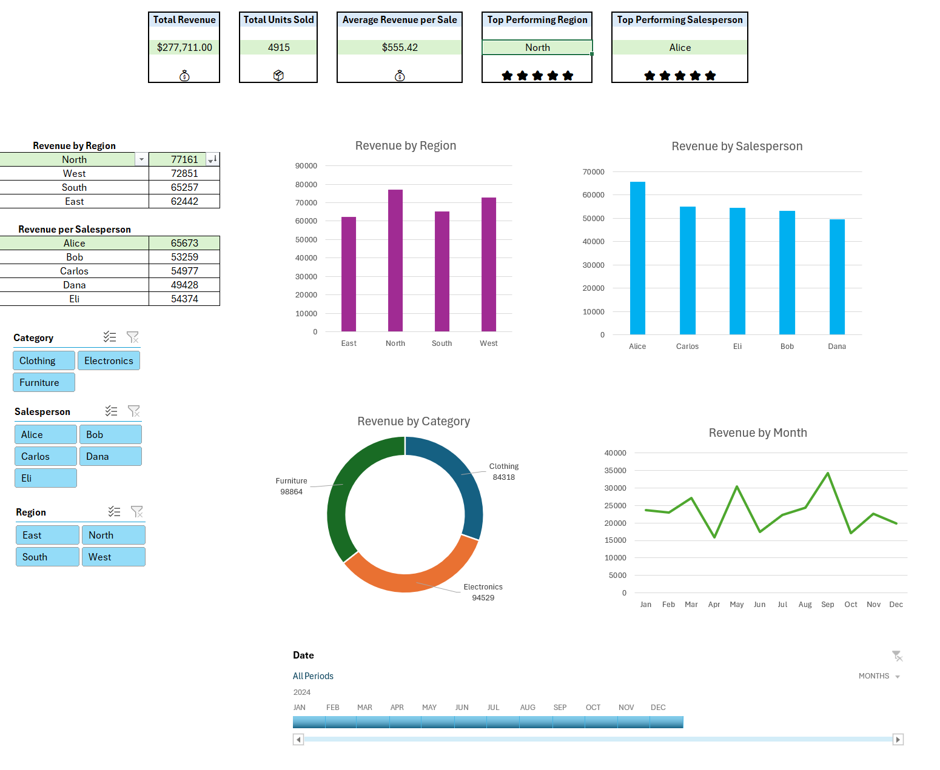

# Key Insights

• North region had the highest revenue, exceeding the second highest region, West, by 1.5% of the total revenue.  
• Alice was the top salesperson with consistent growth across all quarters.  
• September was the strongest month with May coming in second for revenue.

# Learning Reflection

This project helped me strengthen my ability to build executive-ready dashboards, apply advanced Excel formulas, and present insights clearly.

# Next Steps

I would like to have had historical data to show more growth over time.